

NORTH COUNTRY HOSPITAL
Get help paying for health care.
We have a financial assistance program to help you afford the care you need.
What is the financial assistance program?
We give free and low-cost care to people at North Country Hospital. It is for people who are uninsured and for people who have insurance with out-of-pocket costs. It can be used for ongoing care and emergencies. The care must be medically necessary for your health.
Who can get financial assistance?
To qualify:
- Your income must be less than the limit. There are different income limits for free and low-cost care. See the charts.
- Your “liquid” resources must be less than the limit. These are cash, checking and savings accounts, etc. (Your primary home, car, and retirement accounts will not count against you.)
Income limits
Find your household size and income on the charts below. For most people, your household size will be the people listed on your taxes. If you make too much money for free care, you might qualify for low-cost care.

Free care
You could get free care (pay $0) if your household income is below 250% of the Federal Poverty Level. In 2025, your income would need to be less than:
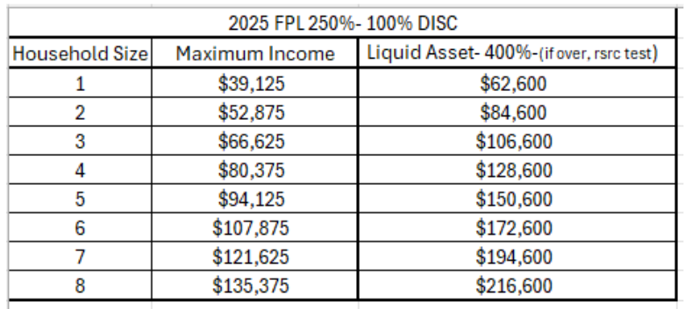
Low-cost care
You could get a 40% discount if your household income is below 400% of the Federal Poverty Level. In 2024, your income would need to be in this range for your household size:
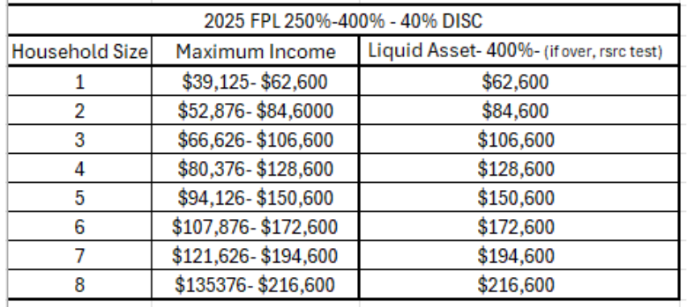
Catastrophic care
Ask us about catastrophic care if you owe the hospital a lot of money, but your income is too high to qualify for free or low-cost care. It is for people with income that is less than 600% of the Federal Poverty Level and who owe more than 20% of their yearly income to the hospital for out-of-pocket costs. We can help you figure out if this could help.

**More information on next page**

How to apply
You can apply before or after you get services. If you apply after you get services, you must do this within 365 days, (one-year) of getting the first bill.
Follow these steps:
- Get a free application.
  - In-person: 189 Prouty Drive Newport, Vermont.
  - Online: https://northcountryhospital.org/.
  - By mail: Call 802-334-3210 ext. 4204 and ask us to mail you a copy for free.
- Fill out the application.
- Give or send us your finished application with requesting documents.
  - “Income” Provide at least one: most recently filed federal or state income tax return; if taxes are not filed, paystubs or other documentation accepted as valid documentation of income by the Vermont Department of Health Access, such as a bank statement, profit and loss statement, letter from an employer, or self-attestation in extenuating circumstances in which no other documentation is available.
  - “Liquid asset” Proof of asset that is cash or can be easily converted to cash such as checking and savings accounts, money markets, stocks, bonds, and certificates of deposit.
  - Drop it off at: 189 Prouty Drive, Newport, Vermont
  - Mail it to: North Country Hospital
Attention: Financial Navigator
189 Prouty Drive
Newport, VT 05855
What happens next?
You will get a letter from us in the next 30 days. It will say if you are approved, denied, or need to send more information. If it has been more than 30 days and you do not get a letter, please call us: 802-334-3210 ext. 4204.
How to get help
You can get free help with the application.
- Visit our financial counseling office:
at 189 Prouty Drive or
186 Medical Village Dr, Newport, VT.
- Call: 802-334-3210 ext. 4204.
- Email: Navigators@nchsi.org
Free language support
We give free help to people who have communication or language needs. We can give interpretation and translation support. We can also help those who need this information in different ways. Tell us if you need language support.
More information
Who accepts financial assistance?
Everyone who works for the hospital accepts financial assistance. There are a few people and groups that can give people services at the hospital who do not accept it. You can find the list here: https://northcountryhospital.org/. Or ask us about your doctor.
Read the full policy.
This is a plain language summary of our financial assistance policy. Read the longer version with more details here: https://northcountryhospital.org/. Or ask us for a free copy.
Non-discrimination
We do not discriminate based on race, color, sex, sexual orientation, gender identity, marital status, religion, ancestry, national origin, citizenship, immigration status, primary language, disability, medical condition, or genetic information.


Financial Assistance Application
Return to: NCH, 189 Prouty Drive, Newport VT 05855
802-334-3210 ext. 4204
___________________________________________________________________
1. Patient’s Information: Self All personal information will be held in strictest confidence.
________________________________________________________________________________________________________________________
First Name Last Name Middle Initial Date of Birth Date

________________________________________________________________________________________________________________________ Street Address City State Zip Length at this Address

________________________________________________________________________________________________________________________
Mailing Address City State Zip

________________________________________________________________________________________________________________________
Home Phone Number Work Phone Number Cell Phone Number Email

2.Person Responsible for Paying the Bill

________________________________________________________________________________________________________________________First Name Last Name Middle Initial Phone Number Home Work Cell

3. ***Please list ALL people living in the household, including applicant: Use additional paper if needed

Name Relationship to Patient Age Date of Birth Current Health Coverage
1._______________________Self___________________________________________________________________________________________
2._____________________________________________________________________________________________________________________
3._____________________________________________________________________________________________________________________
4._____________________________________________________________________________________________________________________
5._____________________________________________________________________________________________________________________
6._____________________________________________________________________________________________________________________

4. Have you applied for financial assistance at another facility? Yes No Where? ______________________

5. Is anyone in your household pregnant? Yes No Whom? _______________________________

6. Is anyone in your household currently uninsured? Yes No Mark No under Current Health Care Above

7. If you are uninsured, did you apply for insurance through the Health Care Exchange? Yes No
If not, why? ________________________________________________________________________________________________

8. Have you filed a workers’ compensation or motor vehicle accident claim? Yes No
If yes date of accident or injury? ______________ Name of Insurance Carrier? _________________Policy #_________________

9. Is anyone in your household eligible for Social Security Benefits? Yes No Who: __________________________

10. Has anyone applied for Medicaid? Yes No

11. Have you been denied health care? Explain _____________________________________________________________________

12. Household Income Information Person 1 Person 2 Person 3
NAME of Household Member | Are You a Tax Dependent (yes/no)
(MONTHLY INCOME)
Employment |  | $ | $ | $
Self-Employment |  | $ | $ | $
Investment Account |  | $ | $ | $
Real Estate (i.e., Rentals) |  | $ | $ | $
Unemployment |  | $ | $ | $
Retirement (Social Security) |  | $ | $ | $
Alimony  Settlement Year: _____________ |  | $ | $ | $
(LIQUID ASSETS)
Checking Account |  | $ | $ | $
Savings Account |  | $ | $ | $
Certificate of Deposit |  | $ | $ | $
Money Market
Mutual Funds/Stocks/Bonds |  | $ | $ | $
Other Savings/Investments/Property  Specify: (_______________) |  | $ | $ | $
LIST OF VEHICLES |  | Make | Model | Year
Car
Car
Truck

PLEASE READ CAREFULLY AND SIGN BELOW

I certify that the information in this application is true and accurate to the best of my knowledge. I understand that if I knowingly provide untrue information in this application, I will be ineligible for financial assistance, any financial assistance granted to me may be reversed, and I will be responsible for the full payment of the hospital bill.

Signature of Applicant: _______________________________________________ Date: ______________________________

Signature of Applicant: _______________________________________________ Date: ______________________________

