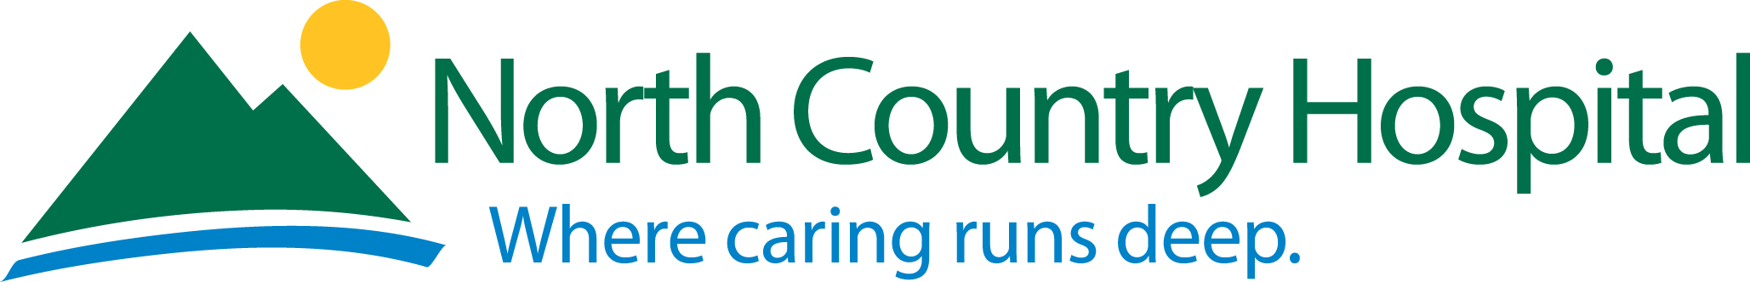

Price Change Effective July 1, 2025 Price changes Highlighted
Product | Price
Heartsaver Student Manual | $6.00
Heartsaver Card | $22.00
Heartsaver in schools’ card | $6.00
BLS Completion Cards/ACLS Completion Cards | $7.00 / $9.00
BLS for Healthcare Providers Student Manual | $20.00
Family & Friends book | $3.00
ACLS Student Manual/PALS | $52.00/$65.00

Course | Cost
Heartcode with individual skills check | $90.00
BLS Healthcare Provider Initial (currently not available) live class | $90.00 (including book)
Heartsaver CPR/AED | $50.00 (including book)
Heartsaver CPR/AED with First Aid | $80.00 (including book)
Family & Friends | $30.00 (book and supplies included)
Heartsaver skills check (1/2 hour) | $45.00
Heartcode skills check (1/2 hour) | $45.00
ACLS/PALS Heartcode skills check | $100.00
ACLS Prep Course | $60.00 for 3 classes or $20.00 per class
ACLS Provider Initial blended learning | $360.00 (book is extra)
ACLS Provider Renewal | $180.00 (book is extra)
PALS Provider Initial blended learning | $360.00 (book is extra)
PALS Provider Renewal | $180.00 (book is extra)

Individual Pricing
Valves | $1.50 each
AED | $1.00 per student
Face Shields | $1.00 per student
Manikin | $4.00 per student
First Aid Supplies | $1.00 per student

